
PROJECT REPORT
Artificial Intelligence – TEXT-TO-IMAGE GENERATOR

Domain: artificial intelligence
submitted by: unees ur rehman kiani
SUBMITTED TO: HIREHIVE LABS

AI TEXT-TO-IMAGE GENERATOR
Artificial Intelligence Project Report

Submitted By: Unees Ur Rehman Kiani
Degree Program: BS Artificial Intelligence
University: CUST
Project Domain: Domain 6 — Artificial Intelligence
Project Title: AI Text-To-Image Generator
Programming Language: Python
Submitted To: HireHive labs

INTRODUCTION/OBJECTIVE

- The AI Text-to-Image Generator is a simple artificial intelligence project that creates images from text descriptions. The user enters a prompt, and the AI model generates an image according to the given description.

- The main objective of this project is to understand how text-to-image AI works and how a pretrained AI model can be connected with a simple Python interface. The project also provides practical experience with Gradio and Hugging Face.

Dataset Used (Name + Link)

- Dataset Name: Not directly applicable. This project does not train a new AI model using a dataset. Instead, it uses a pretrained FLUX.1-schnell text-to-image model through Hugging Face.
- Dataset Link: Not applicable.

This project does not require a dataset because the game operates using a board with nine positions and predefined winning conditions. The AI evaluates possible board states to decide its next move.

Tools & Technologies

The following tools and technologies were used:

- Python: Used to write the main program.
- Gradio: Used to create the web interface.
- Hugging Face: Used to access the pretrained AI image-generation model.
- FLUX.1-schnell: Used to generate images from text prompts.
- VS Code: Used to write and run the project code.

Steps / Methodology

The project was completed through the following steps:

- Step 1: Project Setup
A project folder named AI-Tic-Tac-Toe was created, and a Python file named tic_tac_toe.py was opened in Visual Studio Code.
- Step 2: Installing Libraries
A list of nine positions was used to represent the Tic-Tac-Toe board. Empty positions are displayed as numbers from 1 to 9.
- Step 3: Connecting Hugging Face
The InferenceClient from Hugging Face was used to connect the Python program with the pretrained AI model.
- Step 4: Creating the Image Generation Function
A function named generate_image() was created to take the text prompt entered by the user.
- Step 5: Generating the Image
The text prompt is sent to the FLUX.1-schnell model using the text_to_image() function. The model generates an image according to the prompt.
- Step 6: Creating the Gradio Interface
A simple Gradio interface was created with a text box where the user can enter a prompt and an output area where the generated image is displayed.
- Step 7: Running the Application
The application was run using the command:
py app.py

- Step 8: Testing the Application
The local Gradio link was opened in a web browser. A prompt such as "A cute robot sitting in a beautiful garden" was entered.
- Step 9: Displaying the Output
The AI generated an image based on the given prompt and displayed it in the Gradio interface.
Screenshots of Output / Design

- Figure 1: Python code of the AI Text-to-Image Generator
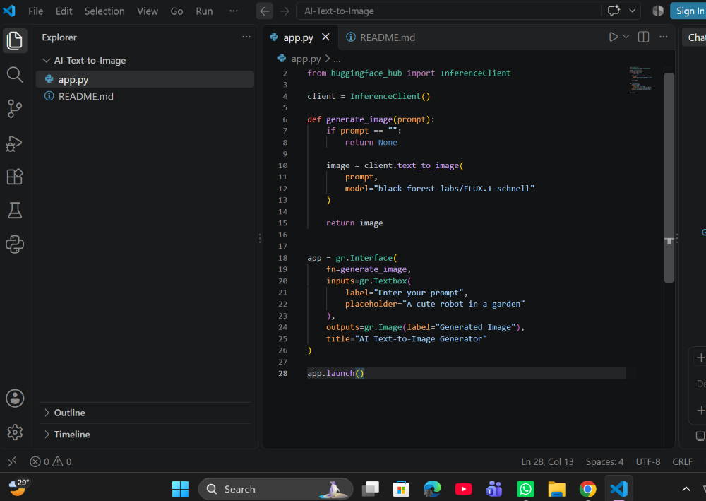

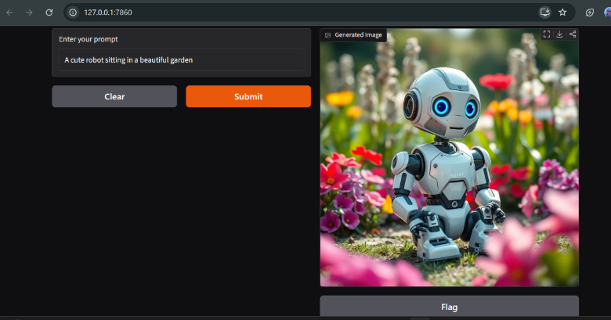
- Figure 2: AI Text-to-Image Generator interface and generated output
Conclusion & Learnings
This project successfully demonstrates a simple AI Text-to-Image Generator using Python, Gradio, and Hugging Face. The application takes a text prompt from the user and generates an image using the pretrained FLUX.1-schnell model.
Through this project, I learned how to connect a pretrained AI model with a Python program and create a simple user interface using Gradio. I also learned how text prompts can be used to generate AI images and how to run an AI application locally.

GitHub Link

https://github.com/Unees-Kiani/AI-Text-to-Image.git

